Lab 3. Basic Chemistry and Properties of Water

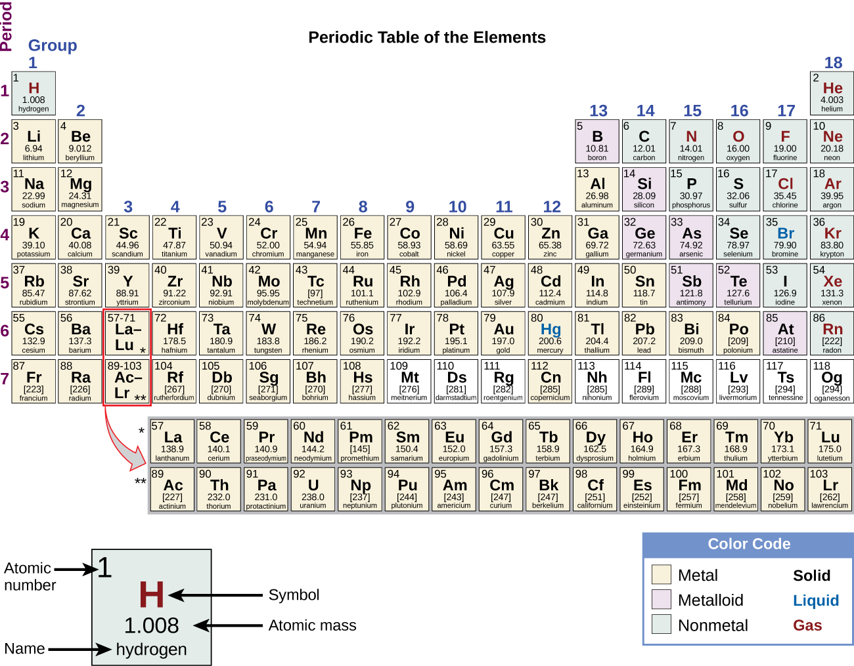

_____________________
Adapted from OpenStax Biology 2e, licensed CC-BY-NC-SA 4.0
A. Basic Chemistry
1. Based on the Periodic Table of Element, answer following questions:
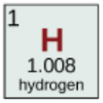 This element is Hydrogen; Atomic number is 1; Atomic mass is 1.008u.
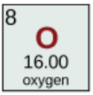 This element is oxygen; Atomic number is—8--; Atomic mass is 16.00u.
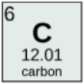 This element is carbon; Atomic number is _6_; Atomic mass is _12.01u__.
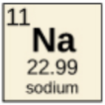 This element is ____Sodium_____; Atomic number is __11__; Atomic mass is __22.99_.
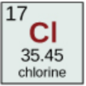 This element is _chlorine__; Atomic number is __17__; Atomic mass is _35.45__.

2. Draw the atomic structures of the above elements and fill in the blanks. In the nucleus, “+” indicates the number of protons; “N” indicates the number of neutrons.
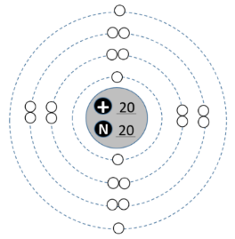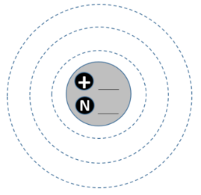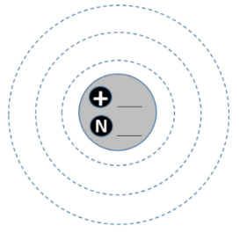
Example: Calcium Hydrogen Oxygen
Electron arrangement: 2,8,8,2 ___1_______ ___2,6_______
Number of valence electrons: 2 ____1______ ____6_____
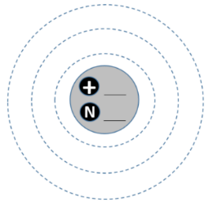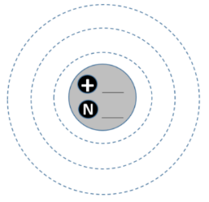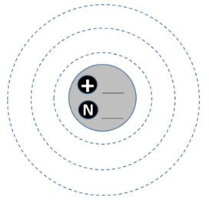
Carbon Sodium Chlorine
Electron arrangement: _2,4__________ ___2,8,1__ __ __2,8,7_____
Valence electrons: ___4_______ _____1____ __7______
3. Compare isotopes: draw the atomic structure of ¹H, ²H, and ³H.
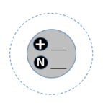
¹H (Protium) ²H (Deuterium) ³H (Tritium)
Atomic mass: 1.00794 amu 2.014 amu 3.016 amu
The difference between ¹H, ²H, and ³H is protium got no neutrons in its nuclei, deuterium is composed of one neutron and tritium is composed of two neutrons
Which isotope is radioactive? Tritium

4. Compare chemical bonds:
a. Atoms of metals and non-metals bond by transferring electrons; this type of chemical bond is called Ionic bond.
Give one example of this type of chemical bond: Sodium Chloride
Draw the atomic structure of your example to show the transferring of electrons.

b. Chemical bond formed by sharing of electrons between two non-metals is called covalent bond.
Give one example of this type of chemical bond: carbon monoxide (CO).
Draw the atomic structure of your example to show the sharing of electrons.

B. Properties of Water
1. Polarity and solvent properties.
- Record your observation and complete the table below.
Test tube | Substance mixed with water | Solubility in water  (soluble / insoluble) | Affinity to water  (hydrophilic / hydrophobic)
1 | Oil | insoluble | Hydrophobic
2 | Alcohol | Soluble | Hydrophilic
3 | NaCl | soluble | Hydrophilic

- Label the type of electrical charge of the water molecule. Use “+” indicates positive charge and “-” negative charge.
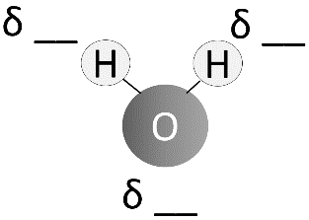

- Chemical bond occurring between the hydrogen atom and oxygen atom within one water molecule is called Covent bond; Chemical bonds occurring between the hydrogen atom of one water molecule and the oxygen atom of another water molecule is called Hydrogen bond.
- Is water polar or non-polar? Polar Why? Has the two hydrogen atoms and one oxygen atom.

- In Cup 2, Alcohol is the solute; water is the solvent.

- In Cup 3, sodium chloride is the solute; water is the solvent.

- Calculate the molarity of a 1L solution that contains water and 12 g of NaCl. (The formula weigh of NaCl is 58.44 g/mol)
_________________________________________________________________________

2. Specific Heat Capacity.
- Record the data collected from the exercise in the table below and calculate the specific heat capacity of Compound Y.
 | Water | Compound Y
Volume (ml) | 100 | 100
Initial temperature (ºC) | 100 | 25
Final temperature (ºC) | 46.6 | 46.6
Density (g/ml) | 1 | 2.78
Specific heat capacity (J/g. ºC) | 4.184 | 3.85

3. Heat of Vaporization.
1) Record the duration for water and alcohol to evaporate in the table below.
 | Drop of Water | Drop of Alcohol
Seconds

- Which liquid drop evaporates faster? Compound Y

3) Which one has a higher heat of vaporization? __WATER__

4. Cohesion and adhesion.
1) The height of water level is 15 cm; the height colored water in the celery stalk is 15cm. What happened to the colored water in the celery stalk? They evaporated faster.

2) The attraction between water molecules is called _cohesion_; the attraction between water molecules and celery is called capillary action.

- Explain how the properties of water are important for plants to transport water from roots to leaves. : Through cohesion and tension, the water molecules tend to cohere and be pulled to the plant stem by the tension force or the pulling force which is exerted by the evaporation happening in the leaves.

5. pH and buffer system.
- Use the online pH meter to determine the pH value of the following substance, and complete the table.
Substance | pH | Basic / Neutral / Acidic | Concentration of H⁺ | Concentration of OH⁻
Drain cleaner | 13.00 | Basic | 10⁻¹³ M | 10⁻¹ M
Hand soap | 9 | Basic
Water | 7 | Neutral
Coffee | 4.85-5.10 | Acidic
Vomit | 2.0 | Acidic
Battery acid | 0.8 | Acidic

- Use the pH paper tool to determine the pH value of the solutions, and complete the table.
Solution | pH
Water | 7.00
Strong acid | 0-3
Weak acid | Less than 7
Strong base | 12-14
Weak base | 7-10

- In bicarbonate buffer system, __carbonic acid__ is the weak acid and _ bicarbonate anion _ is the weak base.

- What is the function of this buffer system in human body? Prevents a radical change in fluid pH.

This work is licensed under a Creative Commons Attribution CC-BY-NC-SA 4.0.

Properties of Water molecule
1) The atomic structure, and include the definition of the following terms: valance electrons, atomic number, atomic mass, and isotopes,
Water molecule is made up of the two atoms of hydrogen and one atom of oxygen. One single atom of oxygen have six electrons in its outermost shell holding eight electrons. The water molecule possess regular crystalline structure consisting of the one oxygen atom covently bonded with the two atoms of hydrogen (H-O-H). The structure of water gives it the polarity nature it possess. It also gives it the lopsided charges, which enable the oxygen, and Hydrogen atoms attract each after they are charged differently.
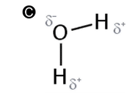
The water molecule has adopted the bent structure and this is due to the two lonely electrons in the oxygen atom.
Valance electron is the outer most electron or electrons in the shell of an atom which is responsible for the chemical properties of that atom. In order to identify number of the electrons, we consider using numbers within certain groups. Atomic number also known as the protons number within a chemical element is the total counts of protons within the nuclei of any atom within an element. It is mostly identical to the nucleus’s charged number. Atomic mass is the average quantity of matter, which is contained in an atom of any element. This is the total weight of all the present isotopes within an element. Isotopes on the other hand are two or more atoms with the same atomic number and are positioned at the same periodic table. Their only difference is on the different neutrons within the nuclei.
2) The three types of bonds and how they are formed, and their characteristics, and include the description of Vander walls forces,
The three major types of chemical bonding include the covalent, ionic and metallic bonds.
Ionic bonding
The ionic bond is formed in the process of metal and non-metal exchanging electrons. In this type of bonding, certain valence electrons within a metal tend to be carried to the non-metal element’s atom in order to achieve its noble configuration.
Covalent bonds
The covalent bond on the other hand is formed when different nonmetals share electrons. It involves certain pair of electrons being shared by the two atoms. In addition, atoms tend to form the covalent bond with the aim of reaching an extreme stable state.
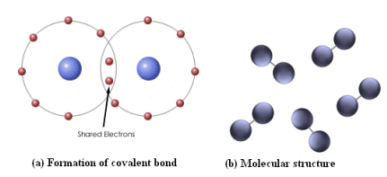
Metallic bonds
This is one of the chemical l bonding which occurs in the
In the metallic bond, metal atoms achieve a more stable configuration by sharing the electrons in its outer shell with many other metal atoms.
Vander walls forces,
According to (Britannica, 2016), Vander walls forces are weak electric forces attract various neutral molecules to each other in liquidified gases, gases, gases as well as any other organic solids and liquids. Solids whose particles are held by the van der Waals forces tend to characterized by lower melting point and they are softer compared to those held by covalent, ionic as well as metallic bonds.
These forces tend to rise from various sources, namely, first, the presence of permanent dipoles molecules, which distort electron charges temporarily in other nearby polar or nonpolar molecules, thus it induces polarization. Secondly, the presence of molecules of some other materials and thirdly and lastly, existing force of attraction
3) Discuss the structure and five properties of water molecules that help sustain life.
The five properties of water which remain to be of great significant to the sustenance of life include, polarity, cohesion, lower density in frozen state, high heat capacity as well as it’s a universal solvent.

Reference
https://whs.rocklinusd.org/documents/Science/2011_Reading_the_Different_Types_of_Bonds.pdf
Structure of Water. (2021, July 5). Retrieved September 22, 2021, from https://chem.libretexts.org/@go/page/53837
Britannica, T. Editors of Encyclopaedia (2016, March 16). Van der Waals forces. Encyclopedia Britannica. https://www.britannica.com/science/van-der-Waals-forces

